

The rules of makeup removal.

Skin care is based on removing makeup: sometimes it is enough to adjust the cleansing process to achieve a noticeable improvement in relief, color, seboregulation and even the acne situation. But even if there are no problems with regular cleansing, questions arise from time to time. I am sharing detailed instructions on makeup removal.

The first and most important thing. Who needs a makeup removal?

Almost everyone. Yes, even for those who do not use decorative cosmetics at all. Check yourself: if you can sign at least one statement from this list, then a demotion is necessary.

• I have oily or combination skin.

• I leave the house during the day.

• I sweat a lot.

• In the morning, I apply facial care.

• I do makeup regularly.

It seems that the makeup removal is only about make-up. In fact, its purpose is to remove everything from the skin of the face except the natural one.

Why is this necessary?

• Firstly, everything that we apply to the skin (cream, tone) is guaranteed to oxidize, forming free radicals (the main cause of aging).

Secondly, sebum from the sebaceous glands cannot freely reach the surface of the skin if all the passages are closed (one of the causes of inflammation).

• And finally, poorly cleansed skin does not perceive the care products applied on top (one of the reasons for dullness). It turns out that it is more profitable to wash off cosmetics in any case than not to wash it off. Even if you really want to go to bed as soon as possible.

Cleansing the skin is not only an evening procedure. It is also necessary in the morning, especially if you use active products at night, and wake up the next morning with a shine in the T-zone.

How not to make a demo: 5 common mistakes:

1. Soap and other alkaline products

Everything is simple here: the pH of the skin is 5.5, the pH of the soap is 9-10. Alkaline soap shifts the acidity of the skin and opens it to infections, and it is through the cells of the epidermis that most bacteria and viruses enter the body. At the first stage of the demaking, the pH of the product should not exceed 6. Even if the number is not indicated on the label, this can be understood by whether the product foams or not (the less foams, the better).

2. Before the creak

A creak is a sure sign that the hydrolipidic mantle of the skin has dissolved along with the impurities. The momentary feeling of cleanliness is quickly replaced by tightness, irritability of the skin, and subsequently by itching and uncontrolled rashes.

3. Napkins

Express methods can only be resorted to as an exception. Wipes are not suitable for regular makeup removal: they only smear dirt, but do not wash them off, contain preservatives, can injure the skin and are extremely unecological.

4. Hot water

Hot water aggressively breaks down fats on the skin and provides shock therapy to capillaries located under the upper layers of the skin. The skin can react to such treatment in any way — from acne to rosacea.

5. Scrub

A scrub is not a means of demaking or even a means of cleansing. This is an exfoliating agent that is applied at a completely different stage and with a different frequency. Scrubs are not suitable for everyday makeup in any form.

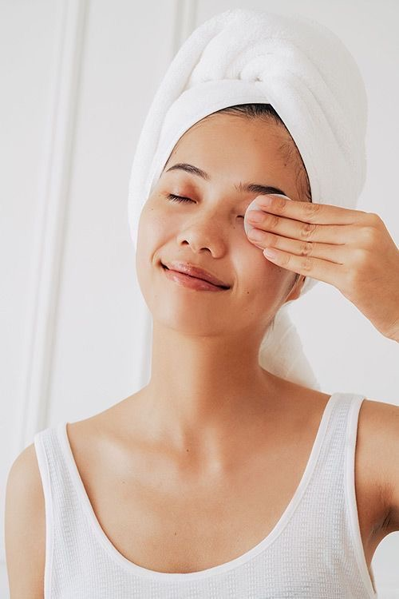

How can I wash off my makeup:

One means is not enough. In the morning, strong remedies are not needed, because you only need to remove the remnants of night cosmetics and excess sebum. And in the evening, there is nowhere without them — dust, sweat, decorative cosmetics are added to sebum and care. For this reason, it would be good to have two products: greasy and foaming.

Such a system is called two-stage purification and looks like this:

* after waking up, washing with a foaming agent;
* before going to bed — make-up with a greasy remedy and washing with foaming.

At the first stage, the contamination must be dissolved, at the second — washed off.

If you complete the process at the first stage (for example, just wipe your face with milk or micellar water), the surfactants themselves and all those particles that we tried to remove will remain on the skin. Consequences: inflammation, bumps, uneven skin tone.

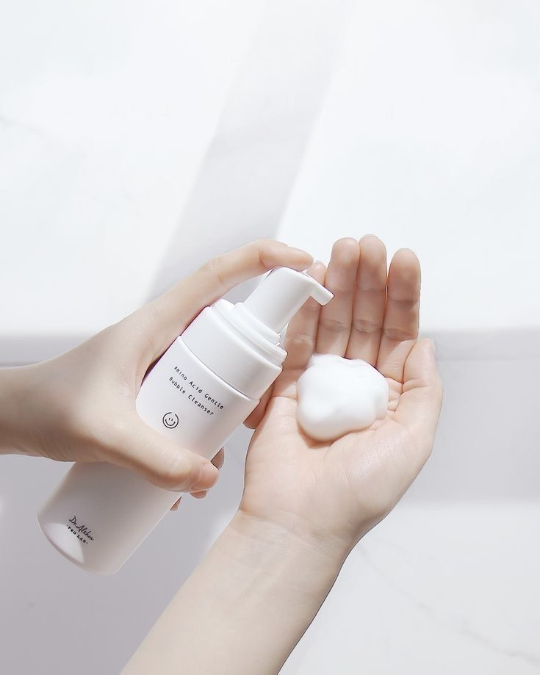

How to find your own pair of funds for makeup removal

Stage 1: means for makeup removal

Format: thick cream, balm, micellar water, milk, oil, hydrophilic oil.

What it does: according to the principle of "like to like", it collects excess fatty particles from the face (from sebum to decorative cosmetics).

Application feature: dry hands on dry skin.

What to pay attention to: soft fatty foods additionally soothe dry and sensitive skin, such products are also good in cold weather, when it literally hurts to touch the skin.

Stage 2: face cleanser

Format: foam, gel, cream cleanser.

What does: It washes off the characteristic film left over from the first product and keeps the skin's own lipid barrier intact.

Application feature: wet hands on wet skin.

What to pay attention to: a neutral pH (about 6). If it is not specified, you can analyze the composition for the amount of surfactants (words with endings in -ate, -ine, -ide). It's okay if the ingredients on -ide are found in the middle or at the end of the list — these are soft surfactants of natural origin, for example lauryl glucoside.

Three sites that we sometimes forget about during the makeup removal

Eyebrows.

During makeup, many people apply three or four products to their eyebrows in stages, but do not pay attention to this area when cleansing the skin. This is fraught with painful inflammation.

Lips.

Even if it seems that there is no trace of morning lipstick, the pores on the skin around the lips are clogged, and the sebum in them oxidizes and darkens.

Hair Growth Line.

Make-up, like make-up, is most effective to do with collected hair, so as not to miss anything for sure. For example, the root zone, where the tone is usually also applied.

How to wash off makeup if I have…

...contact lenses

The ideal option is to remove the lenses and perform a two—stage cleansing. If this is not possible, the product for makeup removal (balm, milk, oil) instead of the skin, you will have to apply it on a cotton pad so that the application can be controlled.

...extended eyelashes

Greasy products dissolve the glue on which the eyelashes are held, so such products are not suitable for eye makeup. The way out is either extremely careful application with a strong indentation from the area around the eyes, or micellar water.

...acne in the active phase

Open inflammations cannot be rubbed with a disc, so everything soft, greasy, thick and creamy that needs to be applied directly to the skin will work as well as possible: from hydrophilic oil to thick balm.

And a few more questions

Is it possible to wash off cosmetics from the face and eyes with the same product?

Of course, if it's comfortable. They do produce separate products for the eyes, but they are needed only for those who are not satisfied with the result of makeup removal a universal product (for example, it does not wash off mascara well or leaves a greasy film).

It seems to me that my remedy does not work well — it does not wash off anything the first time.

It happens that way. For some reason, many people think that if the tool did not work in 5 seconds, then it does not work at all. In fact, most products need at least 20 seconds to break the bonds between the molecules. And if we are talking about waterproof cosmetics or a lot of makeup, then two or three washes in a row may be required.

Do you have to wash your face at all? They say the anhydrous method is better for the skin.

This has not been proven. Manufacturers of micellar water, which supposedly does not need to be flushed, tried to teach us to the anhydrous method. It turned out that it was necessary: in most formulas, surfactants are in the first place, and they cannot be left on the skin. Completely anhydrous washing methods have not yet been invented, but you can remove the products for the first and second stages not with water, but, for example, with a damp terry or muslin towel. The method is good for everyone except owners of acne in the inflammatory stage.

Well, do I need to pick up a wash with special effects? For example, with acids or retinol.

Globally, this makes no sense. Means for cleansing and cleansing are on the skin for such a short time that they cannot bring any moisturizing, regenerating, and even more so anti-aging effect. The best thing such a product can do is to keep the skin neutral pH, so the low pH label is probably the only one worthy of attention.